Executive Function Skills: What They Are and Why They Are Relevant for Workforce Programs?

By LaDonna Pavetti

Achieving success in today’s work place while simultaneously creating a home environment that promotes children’s future success is a complex endeavor that requires individuals to draw on many different types of skills. In addition to the post-secondary credentials that are increasingly needed for success in the labor market and for moving families out of poverty, there is increasing evidence that executive function skills (hereinafter called “executive skills”) that individuals draw upon to successfully achieve short and long-term goals are also important. While there is no one generally accepted definition of executive skills, there is general agreement about what they accomplish—they are the skills that individuals draw upon to set and achieve their goals. They include skills such as planning, prioritization, initiating a task, time management, organization, and staying focused in the face of competing priorities, among others. These skills likely play a significant role in determining whether an individual succeeds or fails in completing an employment, education, or training program or successfully balances the demands of work and family, although other factors such as having supports such as child care and transportation also play a significant role.
Until recently, most of the attention on the development of executive skills has focused on children (and adolescents to a lesser degree), but recent work by Frontiers of Innovation, a project of the Center on the Developing Child at Harvard University, has generated interest in considering whether a greater focus on parents’ executive skills could have positive impacts on both parents and their children. In particular, as a part of their two-generation theory of change, they hypothesize that “interventions that improve the caregiving environment [of children] by strengthening the executive function and self-regulation skills [of parents] will also enhance their [parents’] employability, thereby providing an opportunity to augment child outcomes by strengthening the economic and social stability of the family.”
There is evidence that executive function skills are important for success in many aspects of life, including productivity at work (Diamond, 2013). Several features of executive skills make them relevant for workforce programs. First, they are malleable and can be cultivated and trained across the lifespan. They develop through practice—the more they are used, the stronger they become. Second, the impact of weak executive skills on employment outcomes potentially can be reduced by modifying the demand for them and by matching individuals with jobs that play to their executive skill strengths. Third, several factors that impair executive skills—stress, lack of sleep, lack of exercise, sadness, loneliness, and poor nutrition—are situational and can be mitigated by improving an individual’s environment and helping them to develop supportive social connections.
Although the study of executive skills is a burgeoning field, there has been relatively little attention paid to the development of executive skills in adults – and even less attention to the implications for programs that aim to improve adult capabilities. In addition, much of the available literature is written by and for academic researchers, making it inaccessible to most workforce practitioners. This paper aims to fill this gap by: (1) providing program administrators and staff with information on executive skills that is relevant to the work that they do, and (2) identifying the implications for the design and delivery of workforce programs. By considering this additional dimension of individuals’ strengths and weaknesses, our hope is that workforce programs will develop new models of service delivery that will result in better employment and earnings for the adults they serve in the short-term and better outcomes for their children over the long-term. This is decidedly new territory for the workforce field with no proven executive skill-informed service delivery models on which to build. But, given the modest success of even the best employment and training programs, there is good reason to move beyond what is known to try new approaches.

Substantial Room for Improvement in Employment and Training Programs

Even the most effective employment and training programs have not succeeded in helping the majority of participants to work steadily. Over the years, there have been numerous rigorous studies of employment and training programs, many of them conducted in welfare employment programs. A number of these studies have shown significant impacts on employment, meaning that the individuals randomly assigned to the treatment group (received the program intervention) had significantly higher rates of employment than individuals assigned to the control group (received the standard set of services). This does not, however, mean that the majority of program participants were stably employed after participating in the programs. In fact, as Exhibit A shows, the opposite is true – the majority of program participants did not work steadily. For example, in one of the most effective programs, the Portland Job Opportunities and Basic Skills (JOBS) program, only 38 percent of the treatment group had earnings in four consecutive quarters, compared to 34 percent in the control group.

Evidence that Focusing on Executive Skills Might Improve Employment Outcomes

The Building Nebraska Families (BNF) project—a program that worked with Temporary Assistance for Needy Families (TANF) recipients in their homes in rural Nebraska to increase their life skills and job readiness—provides rigorous evidence a focus on executive skills may help to significantly improve employment stability and increase earnings for very hard-to-employ TANF recipients, that is, those with no high school diploma and little recent employment experience facing multiple personal and family challenges such as mental and physical health conditions, substance abuse, domestic abuse, and low cognitive functioning, among other barriers. While this program was not explicitly designed with executive skill principles and concepts in mind, the program taught and helped participants use such skills as goal setting, time management, stress management and money management, among others. The program was implemented in participants’ homes, but unlike other home visiting programs that are primarily focused on improving health and developmental outcomes for children, this program focused on improving life skills and employment outcomes for parents. Even though the program did not provide employment services directly, it achieved large and statistically significant impacts on employment stability for the very hard-to-employ, a noteworthy achievement for this population. (See Exhibit B.) The program did not produce the same significant impacts for families facing few of these challenges. The three characteristics that distinguished the program from other welfare employment programs were: (1) the program focused on teaching what the program termed “life” skills; (2) services were delivered in families’ homes; and (3) services were delivered by highly skilled, masters’ level educators or counselors.
The program was evaluated using a random assignment design, providing confidence that the improvements in individuals’ employment outcomes were due to the program. Almost half (46 percent) of the treatment group was ever employed for 12 consecutive months, compared to about 30 percent in the control group. These impacts were found among the very hard-to-employ– a group that often does not fare well in employment and training programs. In the final six months of the 30-month follow-up period, participants also had significantly higher earnings and were significantly less likely to report health-related hardships, including poor physical health, self-reported depression, and domestic abuse than those not assigned to participate in the program. The program was expensive, costing an average of about $8,300 per participant, per year for the very hard-to-employ. However, the researchers estimated that if the program was targeted to this group and if the employment impacts observed in the last six months of the follow-up persisted for 1.7 years, the benefits to society would outweigh the costs.

What Are Executive Skills and Why Are They Important?

Although there is a large and growing literature on executive skills, there remains considerable variation in how researchers and practitioners define them. For example, a recent review found that since the early 1970’s when the term “executive” was first used, there are at least 30 different constructs that have been used to describe executive skills. Broadly speaking, executive skills have two primary dimensions directly related to employment and training programs: (1) a process dimension that describes the process of achieving a goal, and (2) a skills dimension that describes the skills that an individual draws upon to complete each of the steps of the process. In this section, we describe three approaches that illustrate these concepts: (1) executive skills as a goal-setting process (Zelazo), (2) building individual executive skills in a practice setting (Guare and Dawson), and (3) interconnection of executive skills and the goal-setting process (Bunge).

Executive Function as a Goal-Setting Process

Philip D. Zelazo, a neuroscientist at the University of Minnesota who specializes in the study of executive function skills in children, has developed an executive function framework focused on goal attainment and problem-solving that is relevant for thinking about executive function skills in the context of workforce programs. (See Exhibit C.) In this formulation, he breaks executive functions into four key components that must be completed in a specific sequence:
- Representation: What is my goal? What is preventing me from accomplishing it?
- Planning: What is my plan for achieving the goal?
- Execution: How will I carry out the plan? What resources/help do I need?
- Evaluation: Did I select the right goal? Did my plan work? If not, what do I need to change? Was my plan realistic? How well did I do at executing it? What can I do differently to get a better result?
An important aspect of this framework is that it makes explicit that there are multiple steps involved in achieving a goal. It also demonstrates that success involves going through an iterative process that repeats itself over and over again. Success in achieving a goal can go awry at any stage. Setting a goal that is not meaningful or unattainable will decrease the chance of success from the very start. Lack of a detailed plan for achieving the goal will make it easy to get derailed along the way while failure to put the plan into action will mean that progress gets stalled, keeping the goal out of reach. Finally, if one fails to continually evaluate one’s progress, it becomes easy to repeat the same mistakes over and over again – or to fail to see that one’s not making any progress.

Addressing Executive Skills in a Practice Setting

Richard Guare and Peg Dawson, mental health practitioners who are the authors, along with Colin Guare of 4 books (with two more on adults currently in progress) on strengthening executive skills (which they refer to as executive skills) in children and adolescents focus their work on the following 12 specific executive skills that one needs to draw upon to successfully achieve a goal:
* Response inhibition | * Sustained attention | * Organization
* Working memory | * Task initiation | * Time management
* Emotional control | * Planning/prioritization | * Metacognition
* Flexibility | * Goal-directed persistence | * Stress tolerance

(See Exhibit D for a brief description of each of the skills and Appendix A for a more detailed description of each of the skills including examples of how strong vs. weak skills play out in individuals’ lives.).
A distinguishing characteristic of Guare and Dawson’s work is that it is based on many years of applying knowledge about executive skills in real life situations. Their model is based on two key assumptions: (1) most individuals have an array of executive skill strengths as well as executive skill weaknesses, and (2) the primary purpose of identifying areas of weakness is to be able to design and implement interventions to address those weaknesses. (Dawson and Guare, [teen book]) They use an executive skills questionnaire to gain a better understanding of an individuals’ executive skills profile. They then use the profile to develop a plan for addressing the behavior that is keeping an individual from achieving their goal.
The executive skills that Guare and Dawson use in their work is a more expansive list than is often referenced in the academic literature. (For example, the literature on executive skills in children often focuses on just three skills: flexibility [or cognitive flexibility], working memory, and inhibitory control.) They have developed this more expansive list because they have found that when skills can be defined specifically, it is easier to create interventions to address those skills. For example, if someone regularly misses appointments, the intervention strategy would be different if the problem arises because of weak time management skills than if the problem arises because of weak inhibitory control or task initiation skills.
The Interconnection of Executive Skills and the Goal-Achievement Process
Silvia Bunge, a neuroscientist at the University of California at Berkley who has done research on the development of executive function skills in adults, has identified three key interconnected executive function skills as especially important: self-control, monitoring and planning. (See Exhibit E.) Self-control (which is related to inhibitory control) is what allows individuals to not get distracted from pursuing their goals; it is what keeps them focused and on track. Monitoring (which relies on metacognition) is what allows individuals to evaluate how well they are doing in meeting their plan for achieving their goals and to be aware of whether their behavior is appropriate for the setting in which they are in. Planning is what makes it possible for individuals to set long-term goals, identify the obstacles and possible solutions for overcoming them, and specify the steps and set appropriate deadlines and reminders for achieving the goals they have set.
Central to Dr. Bunge’s construct of executive skills is the idea that our behavior lies along a continuum with reactive and impulsive behavior at one end and proactive goal-directed behavior at the other end. Executive skills allow individuals to focus their attention and actions on long-term goal-directed behavior instead of immediate short-term impulsive behavior. They also increase a person’s awareness in decision-making by: expanding their vision to include the future in addition to the here and now; considering a variety of factors when making decisions; and factoring in the needs of others as well as themselves.

Building an Executive Skills Informed-Framework for Workforce Programs

Individuals with weak executive skills sometimes find ways to compensate for their weaknesses on their own. But others can’t see their way around them and may find themselves feeling stuck and unable to achieve their goals. The good news for workforce programs is that there are multiple ways they can address weak executive skills, including the following: (1) find ways to reduce the demands on executive skills (for example, change the environment, provide tools to make the task easier–like using a cell phone app for appointment and other reminders); (2) work on reducing things that impair executive skills such as stress, lack of connections, and lack of sleep; and (3) work on explicitly building executive skills: break them into small steps, train them, challenge them and practice in the context in which they will be used. Each of these areas require different investments in agency and staff resources to improve employment outcomes. This section describes how workforce programs might incorporate an executive skills framework and practice model to improve employment goal attainment.

Executive Skills Framework to Achieve Employment Goals

A clear and simple goal setting process is central to an executive skills informed workforce program. Building on the approaches described above, the process described below recasts the executive process and skills in language that is familiar to workforce providers (see Figure F). In addition, this framework draws on the work of Dawson and Guare to identify the executive skills that are associated with each of the four components identified in Zelazo’s goal achievement framework. To make them easier to remember, we rename these components: set, plan, act, and review/revise.
- Set. Establish a goal that is meaningful and achievable. This component draws primarily on metacognition and working memory.
- Plan. Develop a plan for meeting the established goals. This component draws primarily on planning/prioritization, time management, working memory and task initiation.
- Act. Put the plan into action. This component draws on task initiation, response inhibition, time management, sustained attention, and working memory.
- Review/revise. Assess the plan to identify what has and has not worked and revise the goal and/or plan as necessary. This component draws on metacognition, flexibility, and working memory.

Guiding Principles for Direct Practice

Executive skills concepts and principles do not dictate a specific program design or structure, but they do suggest an approach to working with participants that is different from current practices. Fundamental to all of these principles are three core concepts—effort, motivation and time horizon. Using executive skills, especially those that are weak, requires significant effort. Because of the effort required, using weak executive skills results in rapid energy depletion and susceptibility to doing things the way they’ve always been done. Furthermore, not having enough income to make ends meet imposes a “tax” on the brain that leaves fewer cognitive resources to succeed at parenting, education, or work. This means that to promote successful goal attainment, task demands need to be modified to match the person’s capacity for effortful work. Second, motivation is what propels an individual to work to overcome the obstacles that stand in the way of achieving a goal, even when significant effort is required. Adults are motivated by any number of things, including stress relief; success in achieving short-term goals; short-term, frequent and immediate incentives; praise for effort; independence; and autonomous decision making. Third, Individuals with weak executive skills perform best when time horizons are short. When time horizons are short, less effort is required and it is easier for individuals to see the benefit of completing a task or achieving an interim goal. Successfully engaging in short-term goal-directed behavior builds an individual’s executive skills and prepares them to engage in more effortful tasks with a longer time horizon. The principles described below include and expand on these primary concepts.
- Participants are encouraged to set individualized goals that are challenging, but achievable and meaningful to them. Individuals quickly lose interest in goals that are too easy and give up on goals that are too challenging. Workforce programs can help increase the probability that program participants will achieve their goals by helping them to identify goals that are meaningful enough to motivate them to take the steps they need to successfully reach their goals.
- Participants are supported in their pursuit of intermediate goals that have a short time horizon. Intermediate goals with a short time horizon can help sustain motivation to achieve a longer-term goal. Focusing on goals that have short time horizons increases motivation and reduces the perceived effort of completing a task. An intermediate goal that has no direct relationship to employment may provide the best path to stable employment.
- The program helps individuals to recognize their executive skill strengths and weaknesses and identify ways to use their strengths to compensate for their weaknesses. Every individual has executive skill strengths and executive skill weaknesses. Individuals perform best when they are engaged in activities that play to their strengths and rely less on their weaknesses. Importantly, executive skill strengths can be used to compensate for executive skill weaknesses, thus it helps to know an individual’s executive skill profile before making decisions about how to help an individual avoid or overcome roadblocks to success. Goodness-of-fit between an individual’s current executive skills and the environment where they need to apply them is critical for success.
- The program helps individuals improve their ability to handle stress and/or helps them to reduce stress in their lives. Stress impacts an individuals’ ability to engage in effortful tasks. Stress reduction activities are a valued goal and provide a vehicle for practicing executive skills. For many individuals, identifying ways to reduce stress may be the most important starting point for achieving a longer-term goal. The program can also identify way sin which they may directly intervene to reduce the amount of stress in a participants’ life.
- The program understands and supports strategies for modifying the environment to lessen the negative impact of executive skill weaknesses. Environmental modifications can be extremely effective and often are the easiest and cheapest way to help individuals overcome barriers to success. Environmental modifications include such things as providing participants with calendars to help them manage their time or sending appointment reminders via e-mail or as a text message. Modifying the environment reduces the level of effort required to complete a task increasing the chance of success.
- Expectations for an individual are consistent with their ability to engage in effortful tasks. In order for an individual to successfully complete a task, the effort required to complete the task needs to be consistent with the actual or perceived benefit of completing it. Getting the level of effort right may mean the difference between success and failure. If a plan is successfully executed, the level of effort expected should be increased to a level consistent with the individual’s ability to succeed. If a plan is not successfully executed the plan and the action steps need to be revisited and a new plan and action steps developed.
- Coaching is used to facilitate achievement of a goal and development of skills. Program staff can provide critical support for individuals with weak executive skills but it is important that coaches approach their work with the long view in mind. When an individual’s executive skills needed to complete a task are weak, a coach can facilitate development of the skill, but s/he should provide the minimum support necessary and maintain it only as long as necessary. The purpose of coaching is to help individuals move to greater independent action over time. However, support needs to be withdrawn in a planned gradual fashion to ensure the participant’s continued movement forward.
- Coaches help individuals to develop a detailed plan that serves as a roadmap for reaching their goals. The very act of engaging an individual in the process of planning how they will achieve a goal activates and helps to build an individual’s executive skills. A well-crafted plan breaks the path to a goal down into manageable steps. All too often, workforce programs use the same plan for every participant. As a result, the plan provides little or no guidance to help an individual reach their goal.
Applying Executive Skills and Principles: Case studies of Programs Targeting Low-Income Adults
Mobility Mentoring created by the Crittenton Women’s Union (CWU) in Boston is a program that is leading the way in using executive skills and related principles to dramatically change the way we deliver employment and related services to disadvantaged families. At the heart of their program is a goal-setting framework they refer to as “The Bridge to Self-Sufficiency.” This framework includes five pillars: (1) family stability; (2) well-being; (3) education and training; (4) financial management; and (5) employment and career management, with a scaffold for each one. The “Bridge” is used to help participants assess their current circumstances and to set goals for the future. Staff employ coaching techniques to help individuals achieve their goals and they provide incentives when participants reach specified milestones. They also encourage the development of social networks that participants can carry with them beyond their time in the program.
The New Haven MOMS Partnership is an innovative project being undertaken by nine public and private organizations in New Haven, Connecticut. The MOMS Partnership is focused on combatting depression, reducing stress, and building foundational skills that the project hopes will lead to success in multiple dimensions of the participants’ lives, including mental health, parenting and employment. The project has surveyed over 1,000 mothers and has used the information they’ve gathered to design their services and approaches to service delivery. An early indicator of the project’s promise is their success in achieving high levels of participation in one of the key program components – an 8-week cognitive behavioral therapy intervention which the program presents to mothers as a stress reduction program. While the standard for adherence to mental health protocols is usually about 35 percent, the MOMS Partnership has achieved an adherence rate of between 96 and 97 percent. The project is in the process of adding a workforce component that will have a strong emphasis on helping participants to strengthen their self-control skills.

- The program provides opportunities for participants to explicitly work on building EF skills: The program breaks tasks that use EF skills into small steps, teaches the skills required to complete them and provides opportunities to practice them in the context in which they will be used.
- Incentives are used thoughtfully and systematically to help individuals maintain the effort and motivation needed to work towards achieving a longer-term goal. Incentives can be a powerful tool to help individuals engage in effortful tasks and to help them stay engaged with a task until its completion. Incentives serve to increase the perceived benefit of completing a specific task.
- Processes for review and reflection are an integral part of the program. Working with program participants to assess their progress helps them to build self-awareness and also helps them to make adjustments in their plans or goals when they fall short of expectations.

Conclusion

Executive skills principles and concepts provide an opportunity to rethink the design and delivery of workforce programs with an eye towards improving participants’ employment and earnings in the short- to medium-term and children’s outcomes over the longer term. Employment programs for disadvantaged individuals have often produced disappointing results. Thus, these programs are ideal laboratories for developing new approaches and assessing their effectiveness. Programs that take up the challenge of using these principles to develop new service delivery models will join the ranks of practitioners, researchers and policymakers who believe we can and should do better.

Exhibit A

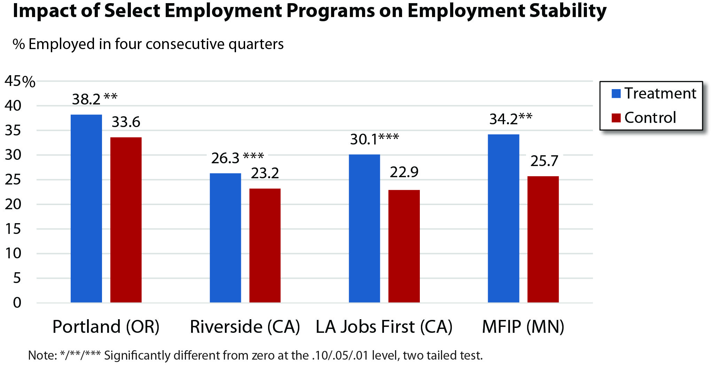
Note: Need to add in cites
Exhibit B
Impact of Building Nebraska’s Families on TANF Recipients with Substantial Barriers

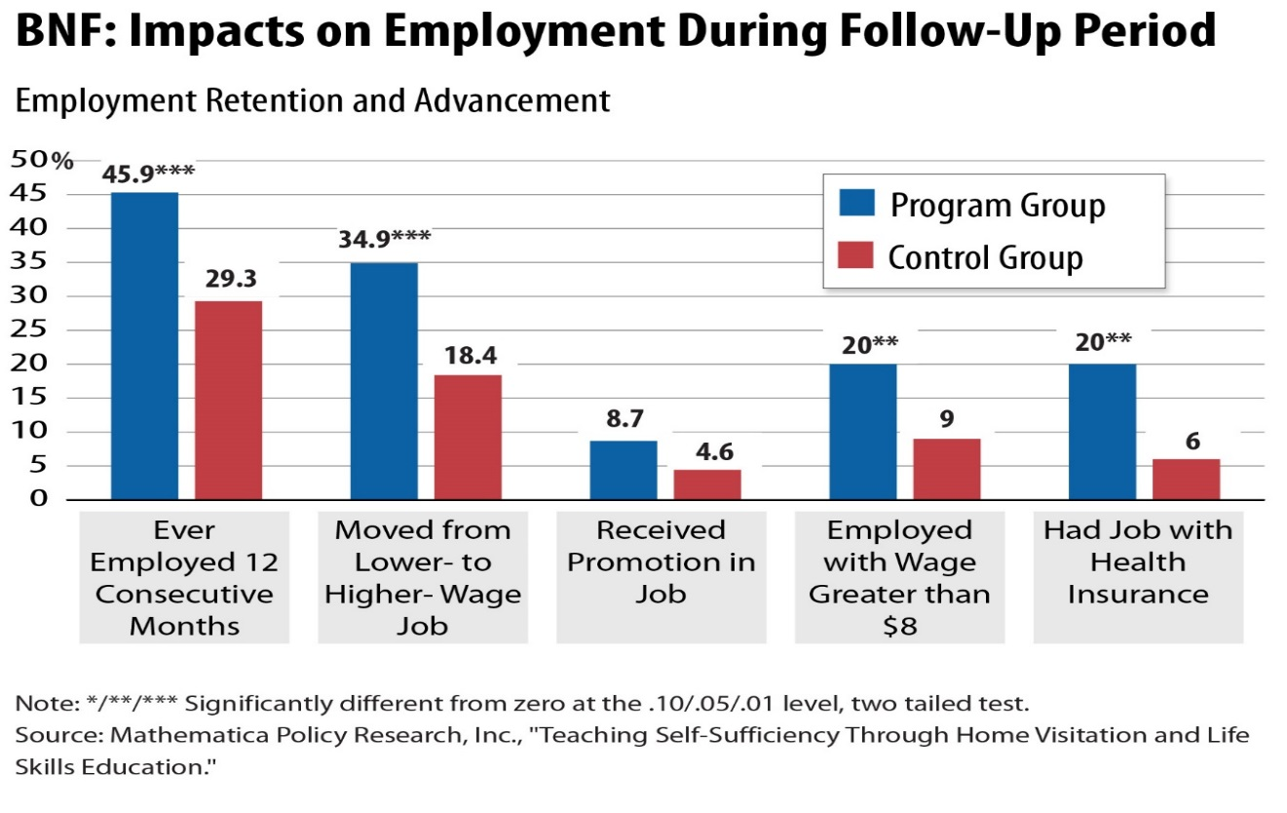

Exhibit C
Executive Skills (Dawson and Guare)
Response Inhibition: The capacity to think before you act – this ability to resist the urge to say or do something allows us the time to evaluate a situation and how our behavior might impact it.

Working Memory: The ability to hold information in memory while performing complex tasks. It incorporates the ability to draw on past learning or experience to apply to the situation at hand or to project into the future.

Emotional Control: The ability to manage emotions in order to achieve goals, complete tasks, or control and direct behavior.

Task Initiation: The ability to begin projects without undue procrastination, in an efficient or timely fashion.

Sustained Attention: The capacity to maintain attention to a situation or task in spite of distractibility, fatigue, or boredom.

Planning/Prioritization: The ability to create a roadmap to reach a goal or to complete a task. It also involves being able to make decisions about what’s important to focus on and what’s not important.

Organization: The ability to create and maintain systems to keep track of information or materials.

Time Management: The capacity to estimate how much time one has, how to allocate it, and how to stay within time limits and deadlines. It also involves a sense that time is important.

Goal-Directed Persistence: The capacity to have a goal, follow through to the completion of the goal, and not be put off by or distracted by competing interests.

Flexibility: The ability to revise plans in the face of obstacles, setbacks, new information or mistakes. It relates to an adaptability to changing conditions.

Metacognition: The ability to stand back and take a birds-eye view of oneself in a situation. It is an ability to observe how you problem solve. It also includes self-monitoring and self-evaluative skills (e.g., asking yourself, “How am I doing? or How did I do?”).

Stress Tolerance: the ability to thrive in stressful situations and to cope with uncertainty, change, and performance demands.

Source: Peg Dawson, EdD and Richard Guare, PhD. (2009). Smart but Scattered. New York, New York: The Guilford Press. (Note: need to figure out the correct way to source this.)

Exhibit D
Executive Function Skills in a Problem-Solving Structure (Zelazo)
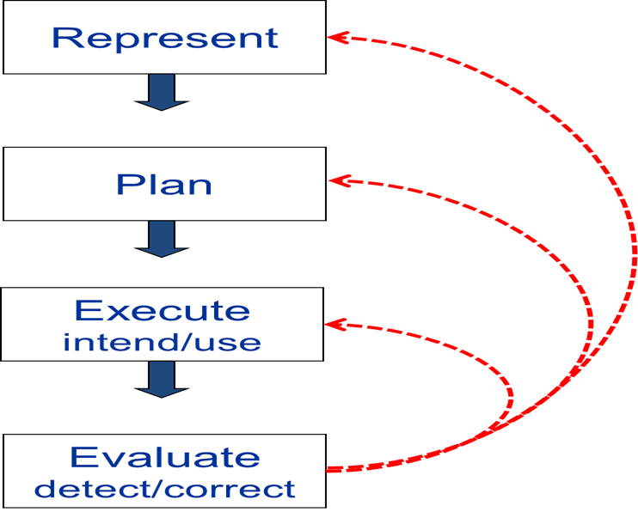

Zelazo, Philip David. (2013) “Executive Function and the Developing Brain.” Conference Presentation: Connecting Brain Science to Practice, St. Paul, MN, November 20, 2013.

Note: This figure should have straight lines showing the connection between the components, not curved and they should be in same color as the boxes.

Exhibit E
Executive Skills That Support Goal-Directed Behaviors (Bunge)
Monitoring
Planning
Self-Control
Reactive
Impulse
Proactive
Goal-directed
Time Orientation
Factors considered
Focus
Future
Right now!
Multiple
One
Self & Others
Self
Executive skills that support goal-directed behavior

Exhibit F
Goal Achievement and Executive Skills

Goal Achievement and Executive Skills

Set
Plan
Act
Review/
Revise
Establish meaningful, achievable goals
Develop a plan for meeting goals
Put the plan into action
Review the plan to assess what worked and revise it as necessary
Metacognition, working memory
Planning/prioritization, time management, working memory, task initiation
Task initiation, response inhibition, time management, sustained attention, working memory
Metacognition, flexibility, working memory
Executive Skills
Goal Achievement Process
Purpose

The other components of the FOI theory of change are: (1) Protecting children from the impacts of toxic stress requires selective skill building—not simply the provision of information and support—for the adults who care for them; (2) Community-based initiatives and broad-based, systems approaches are likely to be more effective in promoting healthy development and reducing intergenerational disparities if they focus explicitly on strengthening neighborhood-level resources and capacities that buffer young children from the adverse impacts of toxic stress.
Alicia Meckstroth, Andrew Burwick, Quinn Moore and Michael Ponza. “Teaching Self-Sufficiency Through Home Visitation and Life Skills Education.” Trends in Family Programs and Policy, Issue Brief #3. Princeton, NJ: Mathematica Policy Research, 2009.
“Introduction: A History of Executive Functioning” by Sam Goldstein, Jack A.Naglieri, Dana Princiotta and Tulio M. Otero in Handbook of Executive Functioning. Edited by Sam Goldstein and Jack A. Naglieri, New York, new York: Springer, 2014.
Philip Zelazo. “What Is Executive Function?” Aboutkidshealth.ca. Accessed from http://www.aboutkidshealth.ca/En/News/Series/ExecutiveFunction/Pages/default.aspx on February 2, 2014.
Elisabeth D. Babcock. Using Brain Science to Design New Pathways Out of Poverty. Boston, MA: Crittenton Women’s Union, 2014.
Megan Smith, (2014). “The New Haven MOMS Partnership: Combatting Depression, Reducing Stress and Building Foundational Skills for Success.” Webinar presented for the Center on Budget and Policy Priorities, January 30, 2014.

